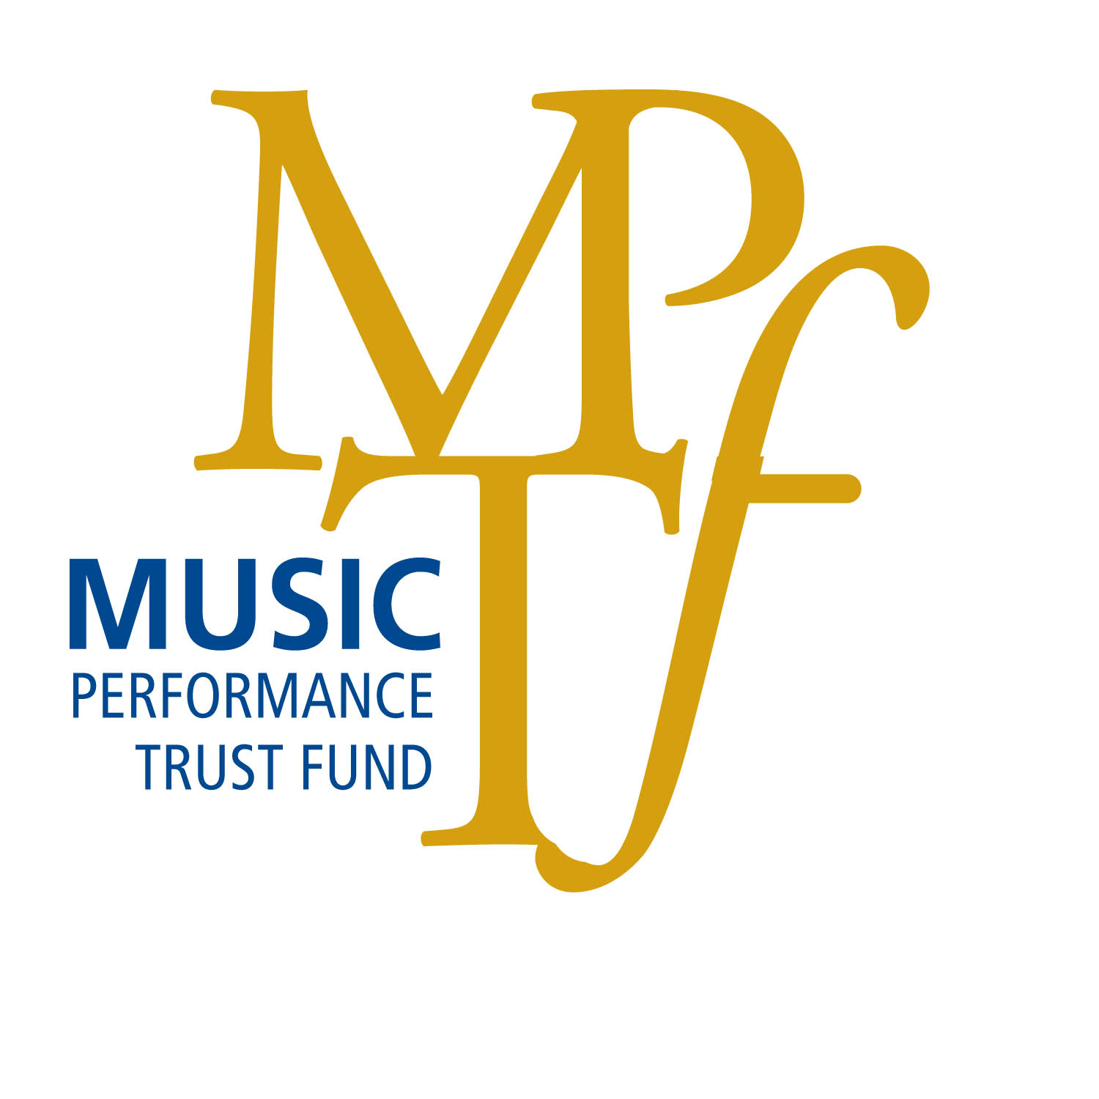
1501 Broadway, Suite 600
New York, NY 10036
tel 212.391.3950 ¦ fax 212.221.2604 ¦ www.MusicPF.org
e-mail info@MusicPF.org

Project #:

0356 660
Area : Local #:

SINGLE PERFORMANCE
AND/OR

PROGRAM SERIES

REQUEST FOR PROJECT FUNDING

LIST ONLY ONE (1) SINGLE PERFORMANCE OR ONE (1) PROGRAM SERIES

Name of Sponsor/Presenter |  | Contact Name
Address | City |  | State/Province
Telephone | Fax |  | Email

Federal Tax Identification Number: | Is the Sponsor/Presenter a 501 (c) (3) Organization?
*Enclose a completed W-9 form with this submission*
Program Goal:

Side musician per  Performance $ __________  Side Musician per  Rehearsal $ __________ |  |  | Contractor And/Or  Leader Performance $ ___________  Contractor And/Or  Leader Rehearsal $ ___________ |  |  | Additional  Contributions |  |  | $
 |  |  |  |  |  | Amount Requested  of MPTF |  |  | $
 |  |  |  |  |  | Grand Total of Costs  For Performances |  |  | $
Perf. No. | No. Of  Musicians | Total Wages of  Performance |  | Employee  Pension Welfare | Transportation or  Cartage Request |  |  | Total MPTF Cost  For each performance
1
2

3

Per. No. | Date of  Perf. | Starting &  Ending Time |  | Performance Location  And Full Address |  |  | Leader/Group  Name |  |  | For MPTF Use
1
2
3

TYPE OF MUSIC (INDICATE PERFORMANCE NUMBER):

